User Manual

April 2015

Version 1.00

Document Revisions

|  |  |  |
| --- | --- | --- |
| Date | Version Number | Document Changes |
| 04/20/2015 | 1.00 | Initial Draft |
|  |  |  |
|  |  |  |
|  |  |  |
|  |  |  |
|  |  |  |
|  |  |  |
|  |  |  |
|  |  |  |

Table of Contents

1 Introduction 5

1.1 Scope and Purpose 5

1.2 Game Rules 5

1.3 Game Requirements & Installation 5

2 Main Menu 6

2.1 Terminology 6

2.2 The Main Menu 6

2.2.1 Starting a Game: 6

2.2.2 Changing the Options 6

2.2.3 Viewing the Control Scheme 8

2.2.4 Viewing the Control Scheme 8

2.3 The Control Scheme 9

3 Playing the Game 9

3.1 How to Play the Game 10

3.1.1 Moving the Camera 10

3.1.2 Moving the Playable Character 10

3.1.3 Navigating Terrain 11

3.2 The Game World 11

3.3 Combat 12

3.4 Losing 12

3.5 Winning 12

3.6 In-Game Menu 13

3.7 Restarting the Game 14

3.8 Changing the Game Options 14

3.9 Collecting Items 14

3.10 Interacting with the NPC 14

3.11 Stamina 14

3.12 Health 14

3.13 Solving the Puzzle 15

3.14 Regaining Health 15

3.15 Quitting the Game 16

# Introduction

## Scope and Purpose

The purpose of this User Manual is to offer a comprehensive description of the Unity Game Capstone Project’s gameplay elements and how the player can play the game. It will cover each feature’s intended use as well as go over the general ideas of how the game should be played. The document’s envisioned use is to be a reference manual for both first time and experienced game players.

## Game Basics

The Game Basics are as follows:

1. The player may explore the island using the mouse and keyboard
2. The player may collect items in the game world
3. The player may engage combat with the enemies in the game world
4. The payer may interact with the NPC in the game world
5. The player may climb up the ladders to the top of the game world

## Game Requirements & Installation

The Minimum Requirements are as follows:

-Intel HD Graphics 4000 Series

-4GB RAM

-Intel i3 Processor

-2 Gigabytes of Storage

# Main Menu

The Unity Capstone Game contains multiple states of play, each with its own purpose and rules. This section will cover the intended use of the Main Menu that the player is presented with upon launch of the game’s executable.

## Terminology

Below are a list of commonly used Acronyms to describe various elements of gameplay

**Demo** - Playable demonstration of core gameplay mechanics

**PC** – Personal computer

**NPC –** Non-player character

**UI** – User interface

**HUD** – Heads-Up-Display

## The Main Menu

The Main Menu Screen is the main driver of the application, allowing the player to begin a New Game, change Visual Options such as Brightness, Resolution, and Graphical Quality, view the Controls or Credits, or to exit the game application and return to the desktop.

### Starting a Game:

1. Open the game executable file.
2. Mouse over the ‘Play’ button on the Main Menu.
3. Press down on the Left Click button of your mouse.

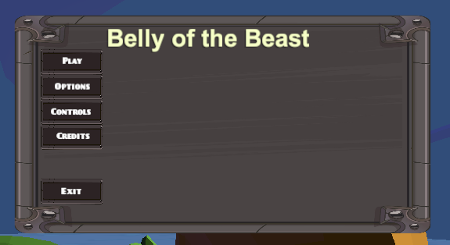

NOTE: This will begin the fully playable game, move to Section 3 for further details

### Changing the Options

1. Video Options:
2. Hover over the ‘Options’ button on the Main Menu.
3. Press down on the Left Click button of your mouse.
4. Hover over the ‘Video’ button on the Options sub-menu
5. Press down on the Left Click button of your mouse.

* Resolution Settings

1. Hover over the ‘Resolution’ button on the Video sub-menu
2. Press down on the Left Click button of your mouse to view the options
3. Choose from the dropdown list the appropriate Resolution settings to match the video output settings of your computer monitor by hovering the mouse over your selection.
4. Press down on the Left Click button of your mouse to select your choice.

* Quality Settings

1. Hover over the ‘Quality’ button on the Video sub-menu
2. Press down on the Left Click button of your mouse to view the options
3. Choose from the dropdown list the appropriate Quality settings to match the graphical quality settings of your computer’s video card by hovering the mouse over your selection.
4. Press down on the Left Click button of your mouse to select your choice.

* Brightness Settings
  + 1. Hover over the ‘Quality’ slider bar on the Video sub-menu
    2. Slide the white button on the slider bar until you have achieved the desired brightness setting for playing the game.

1. Press the ‘Back’ button to return to the Main Menu

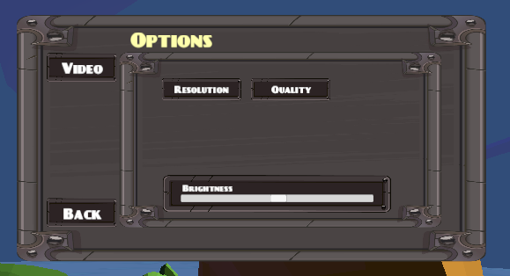

NOTE: These settings will persist until the player exits the game application

### Viewing the Control Scheme

1. Mouse over the ‘Controls’ button on the Main Menu.
2. Press down on the Left Click button of your mouse.
3. Press the ‘Back’ button to return to the Main Menu

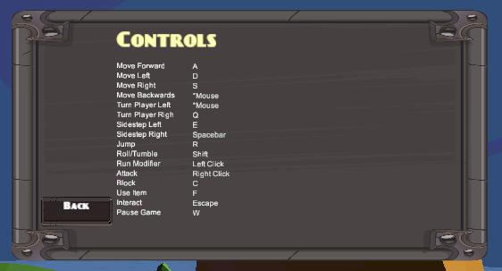

### Viewing the Control Scheme

1. Mouse over the ‘Credits’ button on the Main Menu.
2. Press down on the Left Click button of your mouse.
3. Press the ‘Back’ button to return to the Main Menu

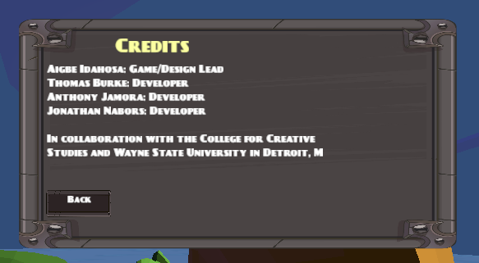

## The Control Scheme

Visible in the Options sub-menu of the Main Menu, the player controls are as follows:

|  |  |  |  |
| --- | --- | --- | --- |
| Class | Action | Key | Description |
| Movement | Forward up | W | Player runs north with forward mechanic |
|  | Forward Left | A | Player runs west with forward mechanic |
|  | Forward Right | D | Player runs east with forward mechanic |
|  | Forward Back | S | Player runs south with forward mechanic |
|  | Turn left | *Mouse | Player turns left |
|  | Turn right | *Mouse | Player turns right |
|  | Sidestep left | Q | Player dashes to the left (*Stamina) |
|  | Sidestep right | E | Player dashes to the right (*Stamina) |
|  | Jump | Spacebar | Player jumps (*Stamina) |
|  | Roll | R | Player rolls/tumbles (*Stamina) |
|  | Sprint | Shift | Player movement is increased (*Stamina) |
| Combat | Attack | Left Click | Player swings sword (*Stamina) |
|  | Block | Right Click | Player raises shield (*Stamina) |
| Interaction | Use item | C | Player uses item |
|  | Interact | F | Player interacts with environment or other characters |
| Menu | Pause game | Escape | Pauses game and brings up menu options |

# Playing the Game

The game player will be spending the majority of their time outside of the Menu System and in the actual, playable game. The below section exists to give a brief overview of each of the game’s main features and functionalities.

## How to Play the Game

The game is played using a combination of the computer’s connected Mouse and Keyboard devices. Reference section 2.3 or the ‘Controls’ screen to see each individual keyboard or mouse command.

### Moving the Camera

The camera sits, by default, behind the playable character, Jomz, providing a third-person viewing angle of the game world. The camera may be moved by moving the mouse in any direction.

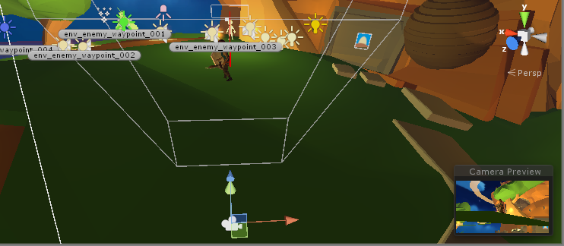

Editor View of how the Camera is rendered. The light blue lines represent the Camera’s viewable space.

### Moving the Playable Character

The player is mainly controlled using the W,S,A, or D keys for moving North, South, East, or West. These keys may be pressed in conjunction with other keys on the keyboard that correspond to various game actions such as Attack or Roll. Additionally, while moving the character in any direction with the W, S, A, or D you may also move the mouse to force the playable character to move in that direction.

### Navigating Terrain

At times, the player character may face difficult in crossing over terrains in the game world. This includes steep slopes, debris, rocks, and other various elements in the game world. Using a combination of moving with the W, S, A, or D keys and pressing the Spacebar will allow the game player to jump over difficult terrain.

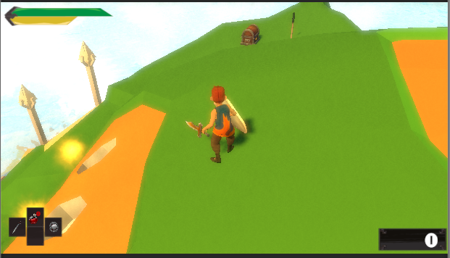

## The Game World

The game takes place on an island surrounded by water. Over time the sun will rise and set giving way to a starry sky and shining moon. The game player will be able to navigate to the top of the island using a ladder system where player can view the world below. See below a bird’s eye view of the playable game world.

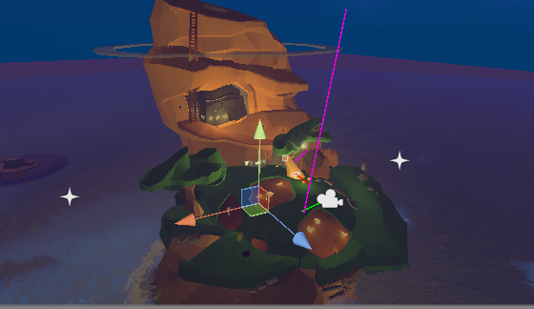

## Combat

Much of the game revolves around combat between the playable character and the enemies encountered in the game world. Combat is resolved by attacking the enemies using the Left Click button on the mouse and blocking incoming attacks by holding down the Right Click button on the mouse.

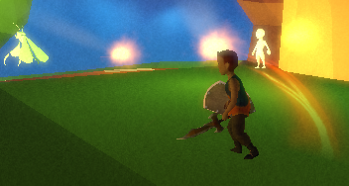 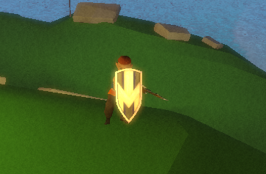

Attacking and Blocking in the Game World.

## Losing

The game is considered lost whenever the playable character’s health reaches zero. This can happen either when the player has taken damage from the enemy character or has fallen from too great of a height. From the ‘Game Over’ screen the player can either Restart the game from the original state or can return to the Main Menu or Quit to Desktop.

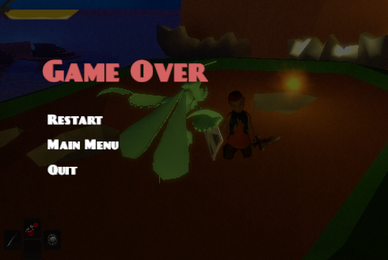

## Winning

The game is considered to have been won whenever the player character successfully reaches the top of the island and jumps through the hole in the middle of the top platform. From here, similar to the Game Over menu, the player can Restart the game, return to the Main Menu, or Quit to the Desktop.

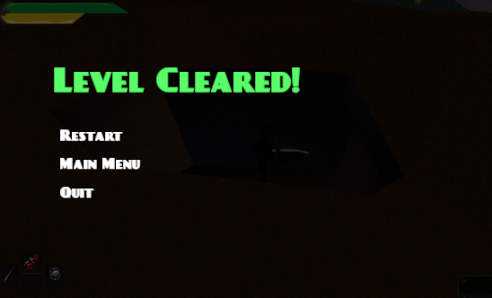

## In-Game Menu

At any time during regular play the player may press the Escape key to pause the game and bring up the In-Game Menu. The In-Game Menu has almost the same selection choices as the Main Menu screen with the exception of the Credits Screen. The only major difference between the In-Game and Main Menu are that the In-Game Menu gives you the option to ‘Return’ to the currently active gameplay session.

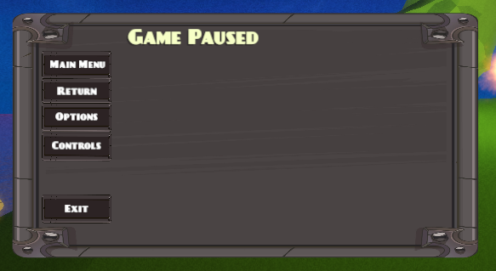

## Restarting the Game

From the In-Game Menu, the player may restart the active game session by selecting the ‘Main Menu’ option and from the Main Menu selecting the ‘Play’ option.

## Changing the Game Options

From the In-Game Menu, the player may make any changes to the available Options exactly how they are done in the Main Menu Screen.

## Collecting Items

The game world contains of two different collectible items that the player may pick up by colliding with them in the game world. These two items are Potions and Essences. Potions are used to regain health and Essences are collected to increase the counter. Essences serve no purpose other than just to collect.

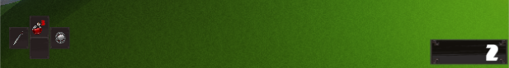

## Interacting with the NPC

The game world is the home of a local Mage named Magus who the player can interact with at any time. Pressing the ‘F’ key on the keyboard while in range of the NPC will cycle through predefined text that the player can read to learn more about the game world.

## Stamina

During regular play, the player character will exhaust his stamina which is represented by a yellow bar in the top left of the screen. Stamina is lost by either holding the Shift key modifier down to force the character to sprint or by swinging the sword by clicking the Left Mouse button.



## Health

The health is represented visually on screen in the form of a green bar. This bar will increase and decrease based on the player’s health value gained from drinking potions or lost from fall damage or successful enemy melee attacks.

## Solving the Puzzle

To progress to the top of the island, the play must solve a player to move an otherwise stationary Boulder blocking his path upwards. This puzzle is solved by pressing the correct combination of switches located in the cave pictured below.

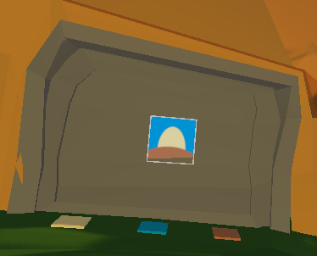

## Regaining Health

During regular gameplay, the player character will lose health either through combat or taking fall damage. If the player has any available potions that they have collected from the treasure chest and their health is below 100%, the player may regain health by pressing the ‘C’ key on the keyboard.

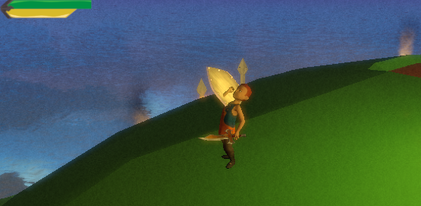

## Quitting the Game

From the In-Game Menu, the player may choose the ‘Exit’ button to bring up a prompt asking if they wish to Quit the active game session and return to the Desktop. This will terminate the game application.

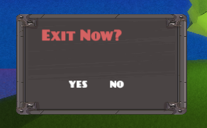

If you encounter issues not addressed by this User Manual, please contact the Unity Capstone Team Lead, Jonathan Nabors at fj2262@wayne.edu.